

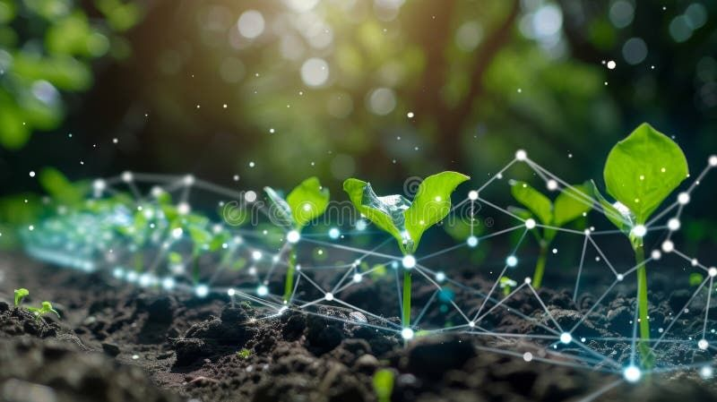
Task: Soil Monitoring System(ARC)
Group 7
Information Systems 325
Group Members:
Olethokuhle Masango(4314391), Madhuri Khanani Ngwenya(4306005), Logan Minnaar(4354381), Kyle Edom(4348792), Niyaaz Gallant(4342262), Bulela Mpetsheni(4344563)

Functional and Non-Functional Requirements of the Soil Monitoring System
Introduction

In this section, we define the functional and non-functional requirements for the Soil Monitoring System developed for the Agricultural Research Council (ARC) Smart Agriculture project. These requirements serve as the foundation for designing, developing, and evaluating the system to ensure it meets both technical and user expectations. Together, these requirements ensure that the Soil Monitoring System is not only technically sound and functional, but also practical, user-friendly, and aligned with ARC’s mission of advancing sustainable smart farming through innovation and data intelligence.

Functional Requirements
In this section, the functional requirements describe what the system must do and describe the specific features, operations, and behaviors needed for the system to perform its intended purpose. They define how the soil sensors, data broker, and front-end application should interact to collect, process, store, and visualize soil health data. Each function is explained in simple, clear language so both technical and non-technical stakeholders can understand how the system contributes to improving soil management, crop productivity, and data-driven decision-making.
Requirement | Description
Sensor data measurement | The system must measure soil parameters including moisture, temperature, pH, electrical conductivity (EC), and nutrients (Nitrogen, Phosphorus, and Potassium) using the soil multi-parameter sensor.
Data collection | The ESP32 microcontroller must collect readings from the soil sensor at regular time intervals to ensure continuous monitoring of soil health.
Data display | The system must show real-time soil readings clearly on any screen, for example a 16x2 LCD display so users can easily view soil conditions.
Data transmission | The ESP32 must send soil data using the MQTT protocol to the Raspberry Pi, which will store and manage the data for analysis.
MQTT publishing | The ESP32 should act as the publisher, sending data messages to the MQTT broker that forwards them to subscribers like the Raspberry Pi or data team.
MQTT subscribing | The Raspberry Pi should act as the subscriber, receiving all soil data messages published by the ESP32 for storage and processing.
Data accuracy | The data soil readings should be accurate.
Calibration | The system must allow calibration of sensors to adjust for differences in soil type and environmental conditions to improve measurement accuracy.
Data Visualization | The system must allow us to build a frontend dashboard/visualization to view meaningful insights from the data soil readings.
System Maintenance | The system must allow easy replacement of components such as sensors, cables, and power jacks without affecting the overall functionality.
Data Storage | The Raspberry Pi must store incoming data readings in a local database or data table so that farmers and the data team can access historical records and we can build visualizations from the data through APIs given by the data team.

Non-Functional Requirements
The non-functional requirements, on the other hand, describe how the system must perform under various conditions. These requirements ensure that the system is reliable, secure, easy to use, scalable, and energy-efficient — qualities that are critical in a real-world agricultural environment where devices operate in remote areas and users may not have advanced technical skills. They focus on aspects such as performance, usability, power efficiency, maintainability, and data security, ensuring the system’s long-term sustainability and user trust.
Requirements | Description
Portability | The system must be easy to move and set up in different farming locations without needing complex installation steps.
Performance | The ESP32 and sensors must provide fast readings, with each full data cycle (reading, displaying, sending) within a reasonable period.
Scalability | The system should support additional sensors or integration with cloud storage or mobile apps in the future without major redesign.
Security | Data transferred through MQTT must be protected using authentication or secure communication to prevent unauthorized access. For example, connecting to the same wifi as the data team’s Raspberry Pi.
Power/Energy Efficiency | The system must consume low power by using sleep modes and efficient wiring so that it can run longer.
Maintainability | The system’s components and code must be well-documented and easy to repair, update, or improve by future teams.
Usability | The system must be simple for farmers to operate, with clear display messages and minimal setup steps.
Reliability | The system must operate continuously for long periods without crashing or losing data during communication or measurement.
Accuracy | Sensor readings must remain within ±5% of the actual soil parameter values after calibration to ensure trustworthy data.

Conclusion

The functional and non-functional requirements together define how the Soil Monitoring System should work with the data team and perform in real-world farming conditions. The functional requirements describe the system’s main operations, such as collecting soil data, displaying real-time readings, and sending information through MQTT to the Raspberry Pi for storage and analysis to the data team.
These ensure that the system delivers the expected results and supports both farmers in monitoring soil health effectively. The non-functional requirements focus on the quality, reliability, and long-term usability of the system. They make sure the solution is accurate, energy-efficient, easy to use, secure, and durable enough for field conditions. Overall, these requirements guide the development of a smart, reliable, and user-friendly IoT-based soil monitoring system that supports sustainable farming and data-driven agricultural research.

